Fish Passage Improvement - Barrier Modification
Concrete Weir and Apron [aka USGS Gauging Station]

Alameda Creek, Alameda County, California

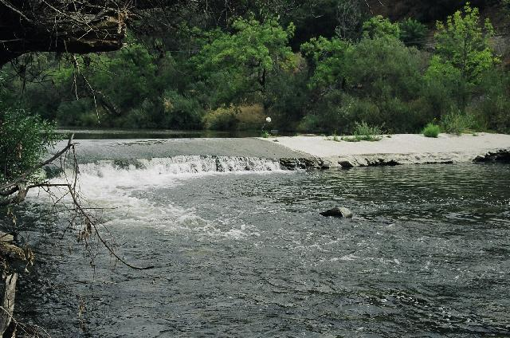
Preliminary Design Report & Project Information
DRAFT April 2005 [Updated 5-12, 24-2006]

Prepared By:

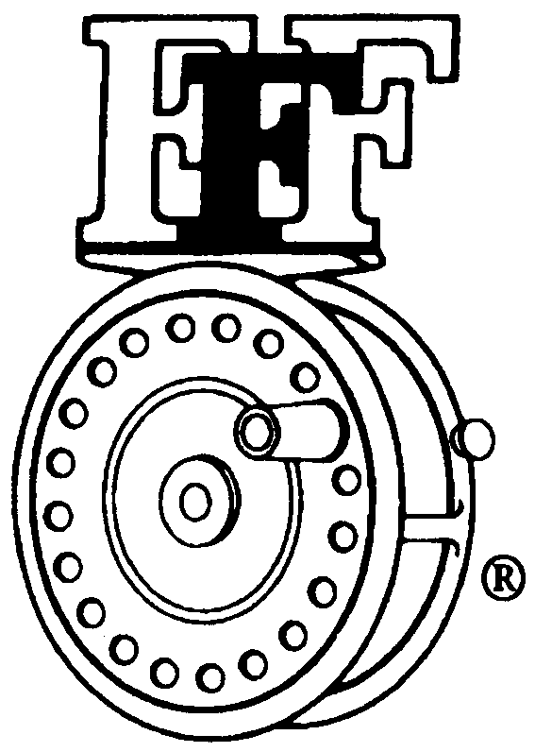 | Federation of Fly Fishers  Conserving-Restoring-Educating Through Fly Fishing  Northern California Council Wild Steelhead Committee  148 Grunewald Court, P. O. Box 7613  Santa Cruz, CA 95061  Phone (831) 588-3817  steelhead@nccfff.org | 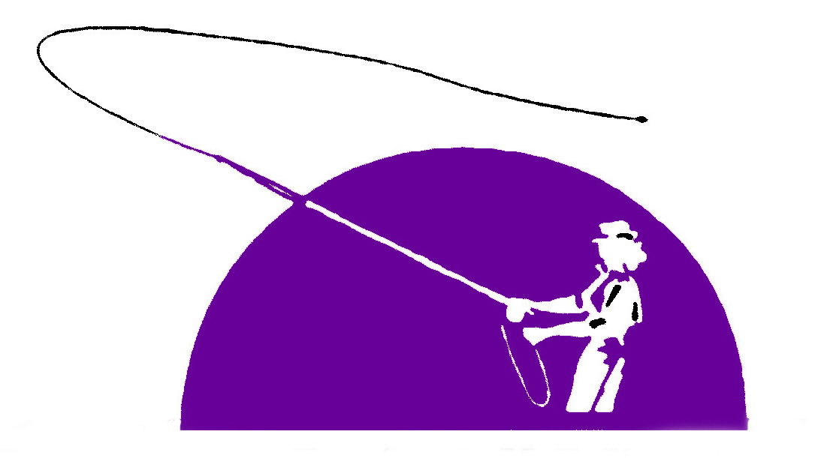 | Golden West Women’s Fly Fishers
Index

Alameda Creek Barrier Locations...................................................................................Page 3
Steelhead on Alameda Creek............................................................................................Page 4
Project Location & Parking Detail Map..........................................................................Page 5
Primary Contact.................................................................................................................Page 6
Project Summary...............................................................................................................Page 6
Details, Significance, Success, Community Involvement...............................................Page 6
Project Work Plan - Significant Milestones....................................................................Page 8
Why this Project is Valuable............................................................................................Page 8
Backgrounds: Project Partner Organizations/Individuals...........................................Page 9
References..........................................................................................................................Page 12
Land Survey & AutoCADD Base Map..........................................................................Page 13
Analysis of Alameda Creek Flows...................................................................................Page 18
Fish Passage Assessment..................................................................................................Page 19
Alternatives Analysis........................................................................................................Page 32
Concept Plan Alternative Concurrence.........................................................................Page 36
Environmental Review Requirements............................................................................Page 37
Construction Permitting Requirements.........................................................................Page 37
Agency and Project Contacts..........................................................................................Page 38
List of Attachments..........................................................................................................Page 44

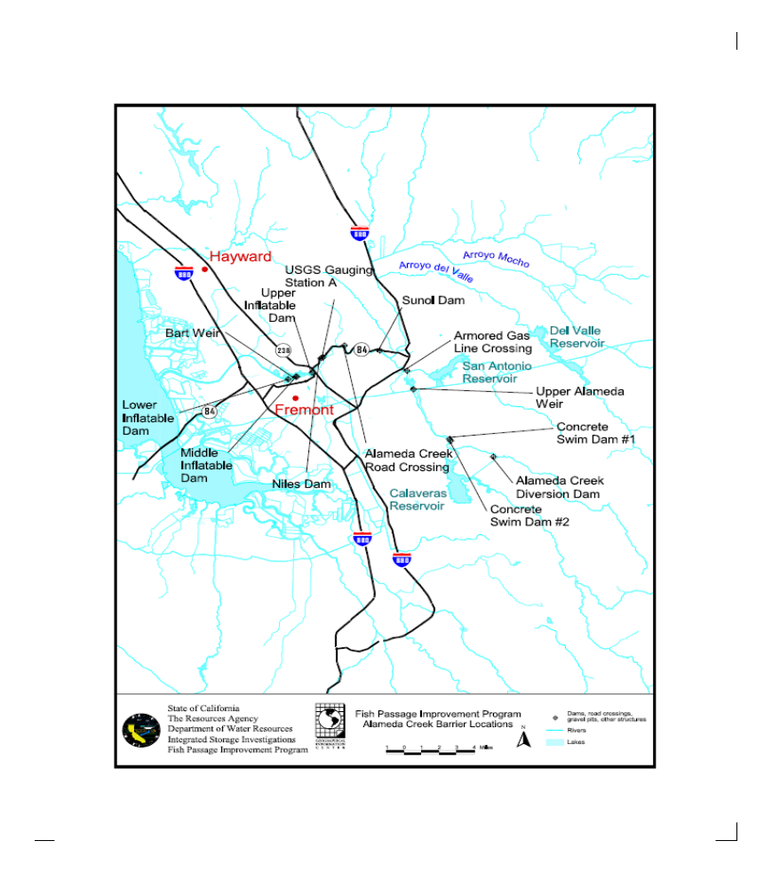
Steelhead on Alameda Creek
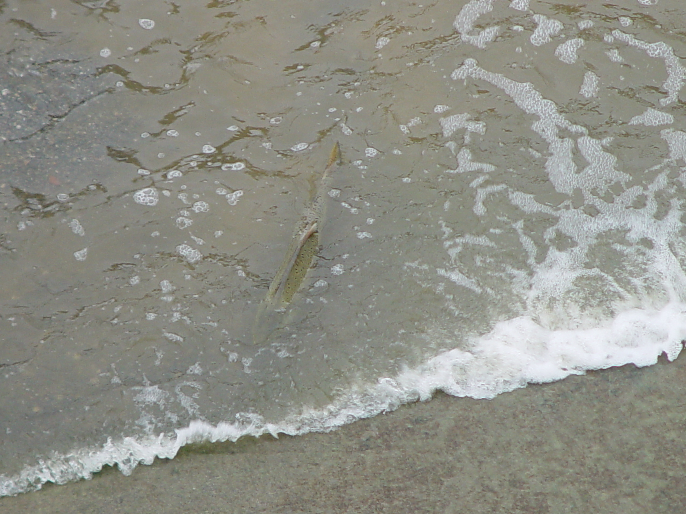 | 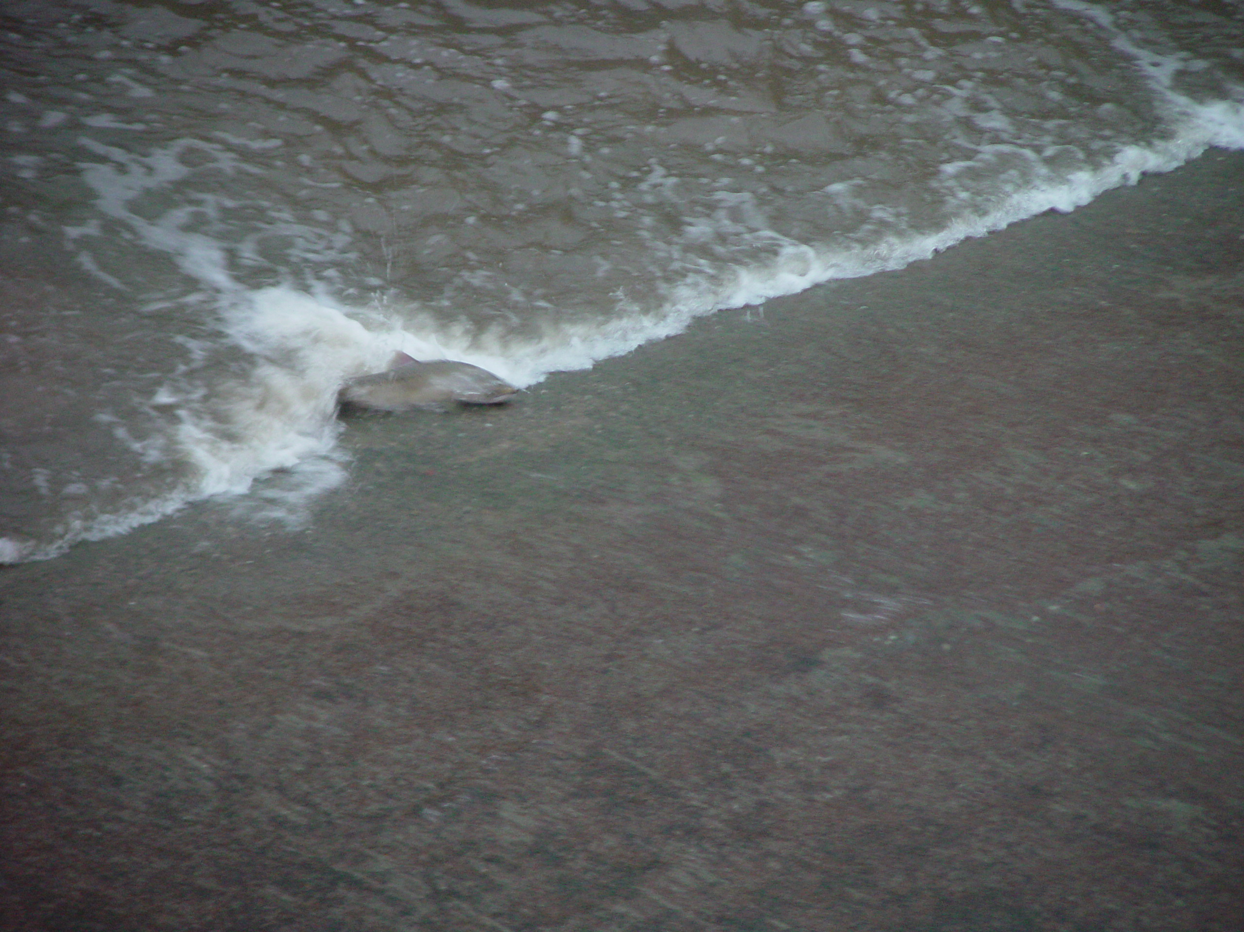
January 2006
 | 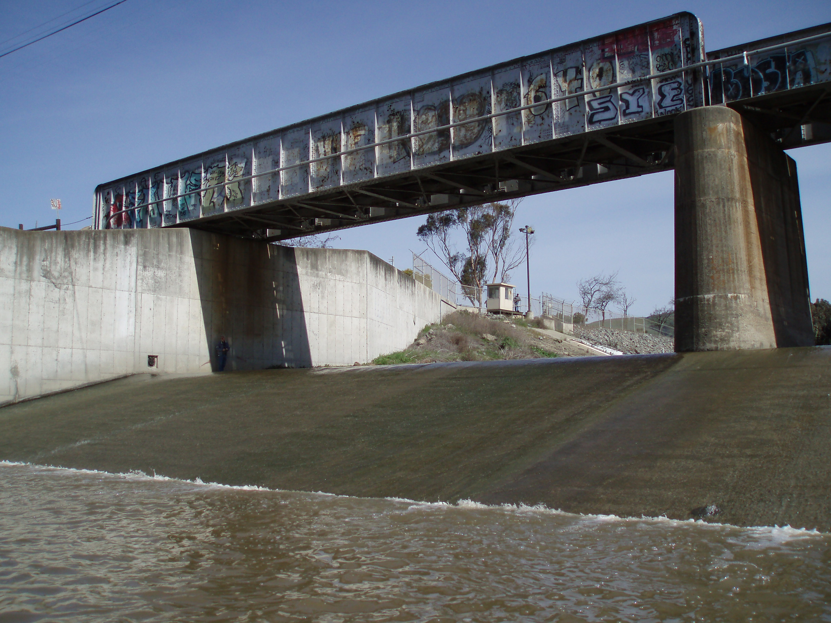 |  | 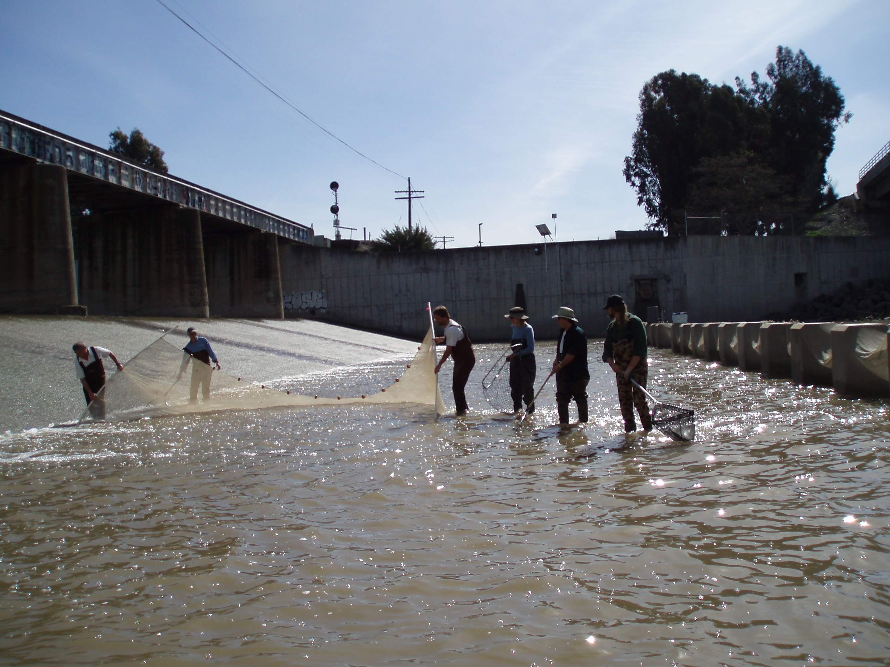
BART Weir on Alameda Creek |  | Seining on Alameda Creek

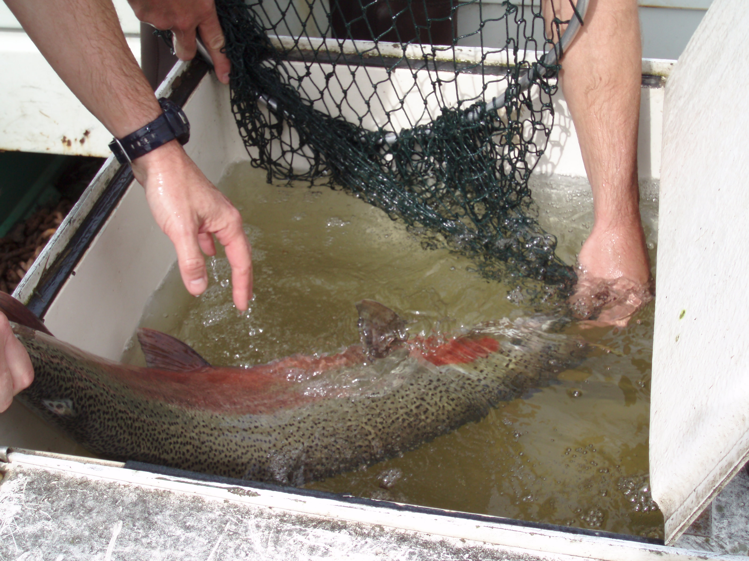

31 inch Steelhead

TO SUNOL
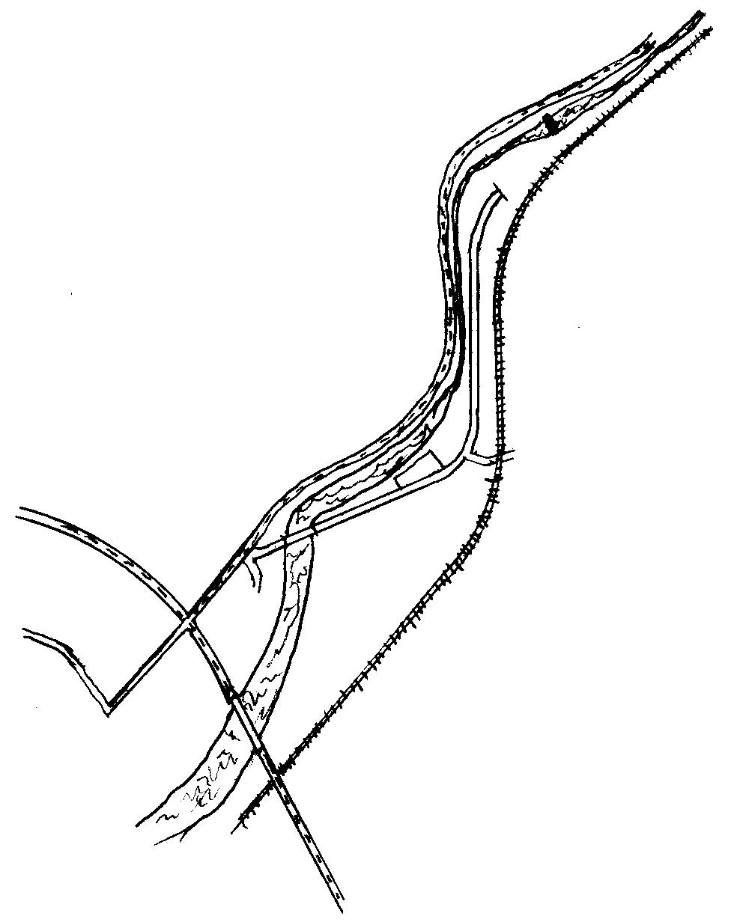
PARK HERE
RAILROAD TRACKS

ALAMEDA CREEK
NILES CANYON ROAD HIGHWAY 84

USGS GAUGING STATION
APPROXIMATE LOCATION - 1 MILE EAST OF JUNCTION OF (238 & 84)

OLD CANYON RD
(APPROX. 200YDS FROM
238 & 84 JUNCTION)
“NILES STAGING AREA”

EBRPD
(APPROX ¼ Mi. FROM 84
ON “OLD CANYON ROAD”)
MISSION BLVD
HIGHWAY 238
JUNCTION OF
“238” & “84”
(MISSION BLVD &
NILES CANYON RD)

TO HIGHWAY 680

USGS GAUGING STATION
Project Location & Parking Detail Map

Primary Contact.

Norman D. Ploss, P.E.
Steelhead Committee – Federation of Fly Fishers {FFF]
Osprey Editorial Board – Journal of the FFF Steelhead Committee
Wild Steelhead Committee - Northern California Council Federation of Fly Fishers [NCCFFF]
P. O. Box 7613
Santa Cruz, CA 95061
Phone (831) 588-3817 [leave message if no answer]
ndeanploss@aol.com

____________________________________________________________________________

Project Summary

In 2003 the Steelhead Committee began participating extensively in fish passage barrier removal in California. The Committee received an initial $2000 grant from the national Federation of Fly Fishers. One part of the grant is to develop a “Model Project” for fish passage, find partners and additional funds to complete the project. Later grants include one from the Golden West Women’s Fly Fishers and another from the NCCFFF. [Other components: engaging in discussion and commentary of the California State Coastal Conservancy Fish Passage Data Base Project.]

The Model Project location is on Alameda Creek in Alameda County, California [San Francisco Bay Region]. GWWFF and NCCFFF provided additional leverage to bring the project closer to construction by providing funding for: Land Surveying, AutoCAD Base Map preparation, this Preliminary Design Report & Background Information to identify fish passage options, a Concept Plan, and outreach to partners, responsible parties, and the public. Additional funds are needed to continue this process. The land survey and fish passage assessment are incorporated into this report.

Alameda Creek Barrier Locations Map (Page 3) and Model Project Location Photo (see cover page) of the concrete apron drop structure near the USGS Gauging Station A on Alameda Creek [California] and Parking Location and Parking Detail Map (Page 5) will orient a reader to its location.

_____________________________________________________________________________

Details, Significance, Success, Community Involvement

Project description:

Land survey, fish passage assessment, develop AutoCAD base map, prepare Concept Plan (30% level of design) to resolve the high, moderate and low flow passage of steelhead rainbow trout at the concrete weir [shown in photo] on Alameda Creek.

Significance:

The Alameda Creek Alliance(ACA) is a volunteer based community watershed group working to restore native steelhead trout to Alameda Creek.

The main impediments to restoring steelhead trout and salmon runs in Alameda Creek are fish passage barriers that prevent adult fish from moving upstream to suitable spawning habitat in the upper watershed. Some of these barriers could also pose problems for juvenile fish attempting to complete their life cycle by moving from fresh water rearing habitat downstream to the Bay.

Largely as a result of community organizing and political pressure by the ACA, there are now 15 local, state, and federal agencies working on anadromous fish passage projects within the Alameda Creek watershed. The Alameda Creek Fisheries Restoration Workgroup is a stakeholders group formed in 1999 to address fisheries restoration issues.

The concrete apron drop structure near the “USGS Gauging Station A” on Alameda Creek is identified as the sixth upstream barrier. It is the last barrier, which needed a “champion” to pursue its modification. Upstream and down stream barriers have been called out by the Alameda Creek Fisheries Restoration Workgroup as higher priority largely due to the nature of the owner being a public entity and to the large cost of modification or removal. The concrete weir and apron near the gauging station was initially considered to be a barrier to juvenile and adult steelhead migration at moderate and low flows. [The Fish Passage Assessment included here indicates the weir is a barrier at all flows.] It is a project that is perfect for a Non Governmental Organization to demonstrate its capabilities.

On the ground conditions will be greatly improved with the elimination of this location being a juvenile and adult steelhead passage barrier.

Prospects for success:

This project has high prospect for success based on several factors:
- Strong public organizing support
- One member of the NCCFFF Steelhead Committee is also a member of the Board of Directors of the Alameda Creek Alliance
- The Agencies with influence over Alameda Creek Fish Passage Barriers are already committed to migratory fish passage improvement
- The project is important and of a “doable size” that can be done in advance of the larger projects and done at substantially less cost [depending on solution chosen]

Community involvement, public education, or press components:

The Project work will be integrated into the efforts of the NCCFFF Steelhead Committee activities highlighting the value of partner’s participation toward final construction. The Federation of Fly Fishers Grant allowed for three presentations. This can be increased as a normal course of completing the project. Additional components can be added to prepare and distribute press releases and placement on the ACA, NCCFFF, and GWFF web sites.
_____________________________________________________________________________

Project Work Plan - Significant Milestones

- Identify Model Passage Project

- Obtain Partner Support

- Secure “Seed” Funding

- Land Surveying of Project Site by Surveyor or Civil Engineer

- AutoCAD Base Map

- Fish Passage Assessment

- Preliminary Design Report & Project Information (modification options) [sometimes referred to as Preliminary Project Development Report]

- Concept Plan [30% level design]

- Community outreach (presentations, press, Web)

- Reports to supporters and participants [The “ Model Project” will be considered complete for purposes of the initial grants at this point.]

- [Environmental Review, Permits, Final Design requires future funding etc.]
_____________________________________________________________________________

_____________________________________________________________________________

Why this Project is Valuable

Leadership
It demonstrates leadership amongst fisheries restoration programs.

Significant Environmental Benefits
The project will identify quantitatively the fish passage improvement by modification of this barrier using fish passage assessment techniques and available background information.

Potential Model
Hugely important!!!! Provide a “Model” by which other NGO’s can follow on the thousands of fish passage barriers on streams recently identified by the California State Coastal Conservancy. Share openly the techniques to pursue steps required to complete fish passage projects.

Demonstrated Program and Project Commitment
Provide evidence of the commitment of the various organizations and agencies involved in management of Alameda Creek to construct this project. Share widely the experience of the Golden West Women’s Fly Fishers, NCCFFF Wild Steelhead Committee and the Alameda Creek Alliance in this project.

Collaborative Effort

Show how the internal and external groups the Wild Steelhead Committee has worked with and this collaboration improved the “Model” Project.

_____________________________________________________________________________

Backgrounds: Project Partner Organizations / Individuals

FFF
NCCFFF is a member Regional Council of the Federation of Fly Fishers (FFF). FFF has grown to over 300 fly-fishing clubs, and the organization is moving more and more toward being an organization comprised of individual members. Our goal is to support fisheries conservation and educational programs for all fish and all waters. Anywhere fly fishers have an interest; the FFF can and does play a role. FFF distributes a national magazine, The Flyfisher. The International Fly Fishing Center in Livingston Montana is part museum, part education center, and is operated by a professional staff. The IFFC is a creation of the Federation of Fly Fishers, and represents how seriously we approach our mission of sharing the fly fishing experience and teaching others conservation. The FFF has also been a sponsor of the Wild Trout Symposiums since its inception. This symposium brings together leading fisheries scientists and conservation activists from around the world to discuss both the present and the future. We offer grants for education and conservation projects, and are generally the leader in helping interested people, whether they are old or young, learn the skills and finer points of our beloved sport.

NCCFFF &Wild Steelhead Committee
NCCFFF represents almost 40 clubs as well as non-affiliated individual members. NCCFFF is the only conservation group exclusively representing the interests of fly fishers in Northern California and Nevada. We have an established Conservation Network and numerous special committees. Our Wild Steelhead Committee actively promotes the restoration of wild steelhead fisheries to sustainable levels. The Mission of this Committee is to heighten the visibility of the Wild Steelhead restoration challenge and promote implementation of key restoration initiatives. These restoration actions notably include opening of barriers to fish passage.

Golden West Women’s Flyfishers (GWWFF)
The Golden West Women Flyfishers is one of the oldest woman fly fishing clubs in the United States, having been founded in 1983. The club has nearly 150 members in Northern California and Oregon and thrives on the passion, sport and art of fly fishing. The club is also a non-profit foundation, which raises funds for conservation efforts, scholarships for women studying fisheries and environmental science as well as for in-school aquarium projects. The Golden West Women Flyfishers has been a long time supporter of restoration efforts on Alameda Creek. Beginning in 1998, elementary school children successfully raised native steelhead under the GWWF Tanks in the Classroom Program using eggs rescued from stranded steelhead in the flood-control channel of Alameda Creek. These fish were released back into the creek by the children and were the first of several years of successful steelhead rescue efforts via the GWWF egg-rearing program.

Alameda Creek Alliance (ACA)
The Alameda Creek Alliance is a community watershed group dedicated to protecting and restoring the natural ecosystems of the Alameda Creek watershed. Their primary mission is protecting and improving habitat for endangered, threatened, and sensitive native species.

ACA’s initial efforts focus on restoring runs of steelhead trout and salmon attempting to ascend Alameda Creek to spawn. Their goal is to ensure self-sustaining populations of these fish. They work to remove or modify barriers to fish migration and to supply adequate water flows for spawning, rearing and out-migration of juvenile smolts to the Bay.

They also work to restore and enhance fish habitat, improve water quality, and prevent habitat loss and degradation caused by development, livestock grazing, and channelization of streams. ACA monitors the public agencies involved in management of the creek to ensure that they comply with existing environmental laws and protect the public trust by providing for protection of fish and wildlife.

Participation or membership in the Alameda Creek Alliance is open to anyone committed to the above goals. Participation in the organization is on an individual basis, not as a representative of any agency, business, or political group. ACA will work with government agencies and private entities interested in supporting their goals.

ACA is an independent non-profit community group. Membership meetings are publicly announced, accessible, and democratically run. ACA respects diversity of opinion and approaches, and will work through education, publicity, advocacy, public pressure, legal action, and volunteer work.

_____________________________________________________________________________

Project Leader

Norm Ploss:
Registered Civil Engineer in the State of California.

Substantial experience in government and private enterprise including:
- Infrastructure design, construction and maintenance
- Capital Improvement Project Financing and Management
- Budget preparation, fiscal analysis and forecasting
- Land use planning including development and environmental aspects
- Contract negotiation, document preparation, and administration
- Rate review and revenue analysis
- Public information and participation
- Watershed Programs, Restoration, and Project Management
- Urban Runoff Clean Water programs and management
- Local government public works, engineering and management
- Regulatory framework and environmental review [NEPA / CEQA]
- Civil and Environmental Programs, Projects; permitting, design and implementation
- Interstate highway and local road financing and projects
- Integrated Waste Management [refuse and recycling]

Steelhead Committee – Federation of Fly Fishers {FFF]
Osprey Editorial Board – Journal of the FFF Steelhead Committee
Wild Steelhead Committee - Northern California Council Federation of Fly Fishers [NCCFFF]
Past Director, Northern California Council Federation of Fly Fishers 2001 - 2006
Past Chair, Wild Steelhead Committee, NCCFFF

Member:
City of Santa Cruz, CA Transportation Commission
County of Santa Cruz, CA Integrated Waste Management Integrated Waste Management Local Task Force as representative of the Public-at-Large

Judge 2004 Business Environmental Awards Program in Silicon Valley [a program of “Acterra; Action for a Sustainable Earth”; www.acterra.org]

Sole Proprietor:
New Dimensions +
Civil Engineering and Environmental Project Management

_____________________________________________________________________________
References
Phil Greenlee, Dave Ford  Past and current Presidents, NCCFFF | Mark Rockwell  Vice President,  NCCFFF, Conservation | Jeff Miller  Alameda Creek Alliance &  Center for Biological Diversity  510 663-0616
Cindy Charles  Golden West Women’s Fly Fishers  1403 Willard Street  San Francisco, CA 94117 | Anne-Marie Bakker  President, Golden West Women’s Fly fishers  1295 Calle del Arroyo  Sonoma, CA 95476 | Derrell Bridgman  Board Member, Alameda Creek Alliance & NCCFFF

Land Survey & AutoCADD Base Map
Across rivers and streams in California 20,000 plus passage barriers to migratory steelhead and salmon exist. Some are dams; many are various forms of road crossings [often culvert pipes], and water diversions. On Alameda Creek one is a concrete weir used to assist measuring stream flow rates.

In late May 2005, the NCCFFF Steelhead Committee with the Golden West Women’s Fly Fishers and Tri Valley Fly Fishers spent a busy day with a registered Land Surveyor at the “gauging station” on Alameda Creek. Hour after hour the surveyor took “shots” of various “cross sections” in the water, along the channel tracing the high water mark, and the roads, trees, utilities, and gauging facilities. The several hundred “shots” were interpreted by computer and to become the n AutoCAD [computer aided design] base map. The fish passage specialist will analyze the base map along with stream flow data to assess the degree to which this facility inhibits migratory adult salmon and steelhead on their way to spawn and young fish moving up and down stream. The base map will be used for detailed discussion and consideration of passage improvement alternatives with regulatory agencies and interested parties. Ultimately the base amp will be used for preparation of a final engineered design of the chosen passage improvement alternative.

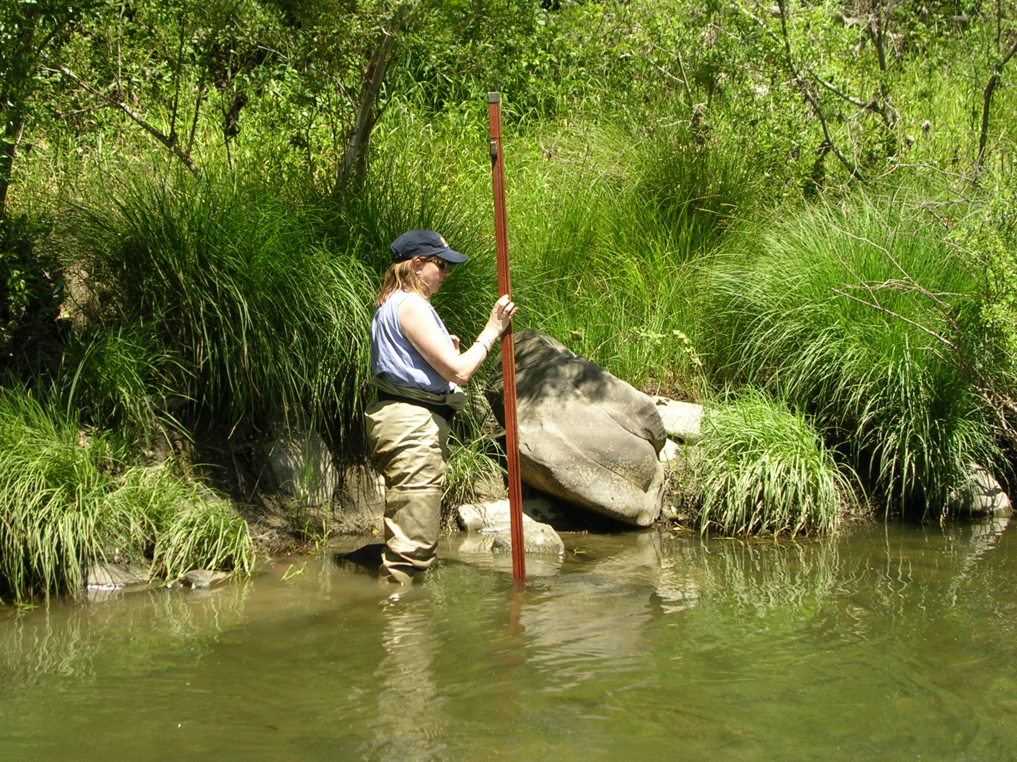 | Cindy Charles of GWWFF holds the “Philly” for a survey point along Alameda Creek

Derrell Bridgman ACA & TVFF and Surveyor locate Cindy for a long “shot” on the streambed. | 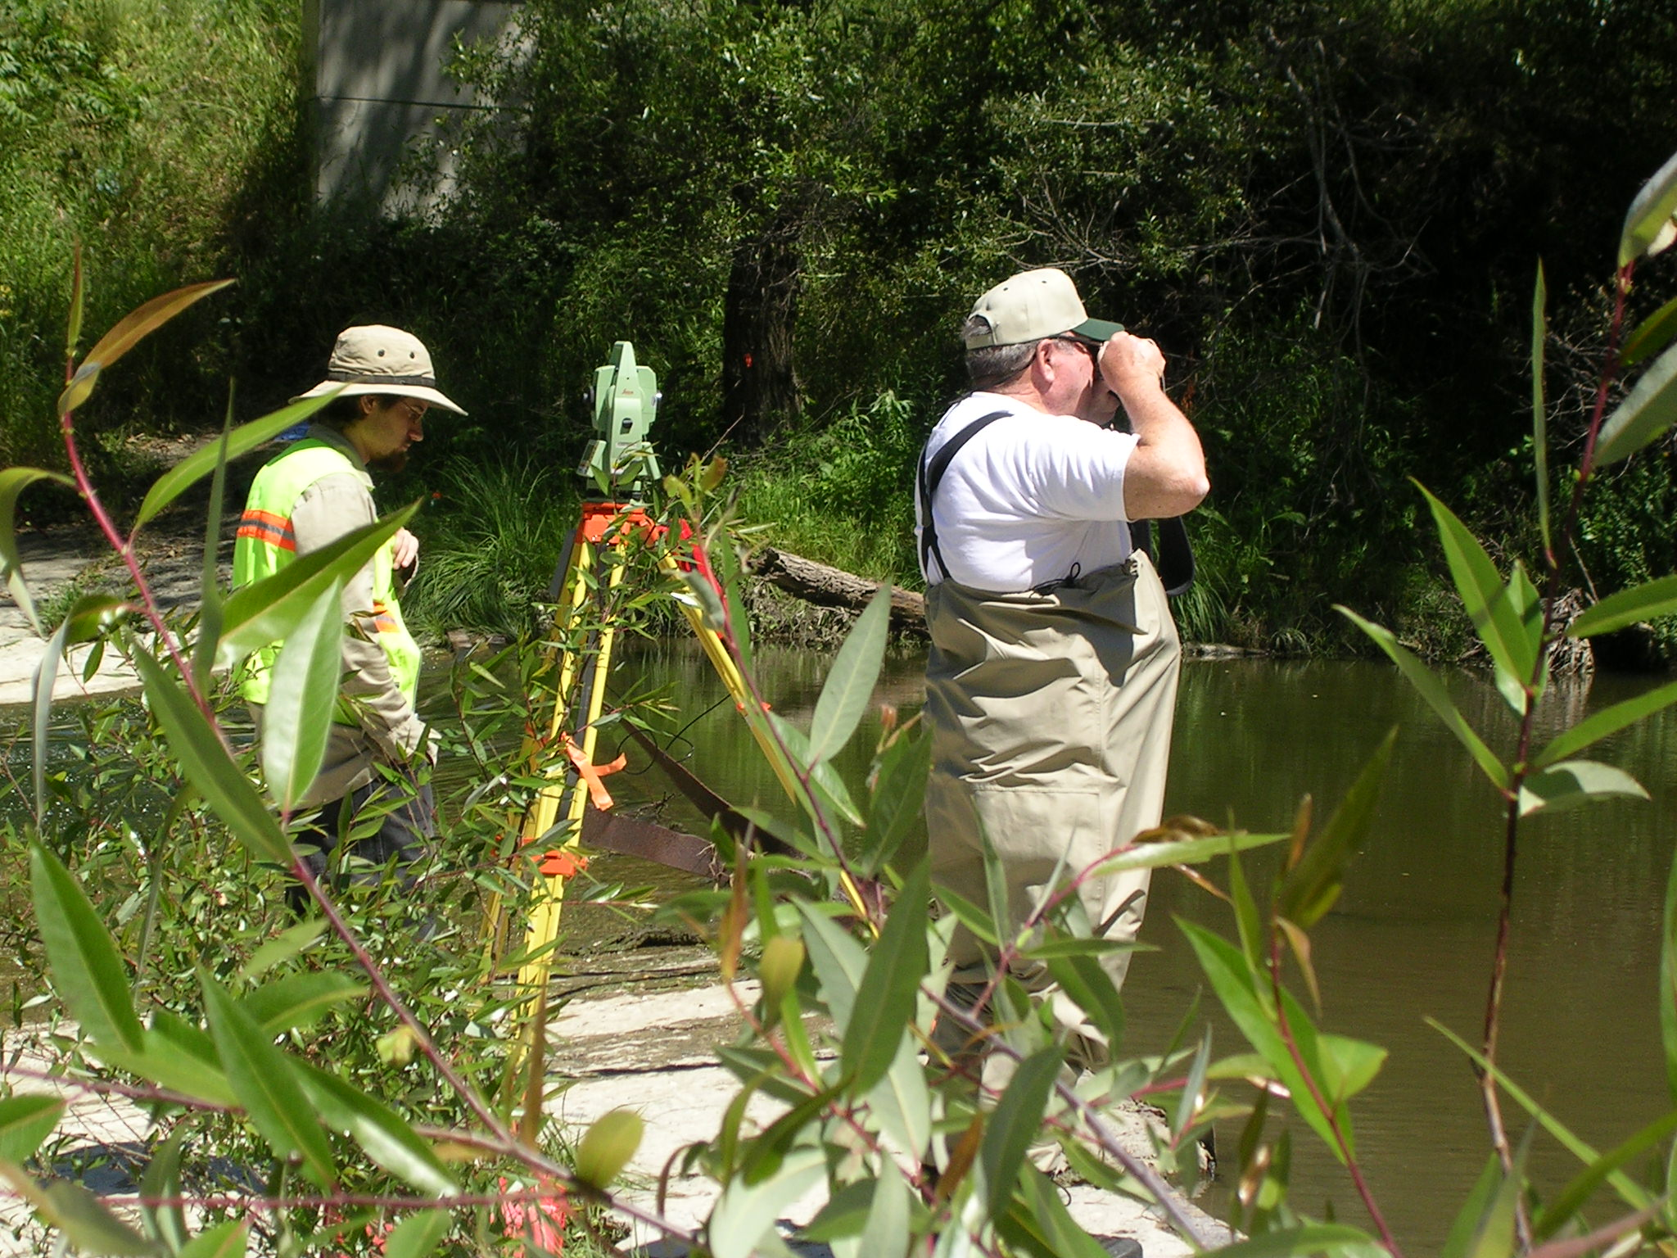

[insert or attach pocket or 11x17’s] 4 pages - leave four blanks
Page 1 of 4 11x17 survey sheets

Page 2 of 4 11x17 survey sheets
Page 3 of 4 11x17 survey sheets
Page 4 of 4 11x17 survey sheets

Analysis of Alameda Creek Flows:
USGS 11179000 Alameda Creek Near Niles, CA
1980-2005 Time Period
10 Data Points Selected
 |  | Maximum |  |  | Calculated
Water |  | Annual |  |  | 75% of Max
Year |  | Flow (cfs) | Date |  | Flow (cfs)
1998 |  | 17,900 | 3-Feb-98 |  | 13,425
1986 |  | 16,400 | 19-Feb-86 |  | 12,300
1995 |  | 15,000 | 22-Mar-95 |  | 11,250
1997 |  | 10,700 | 26-Jan-97 |  | 8,025
2003 |  | 10,400 | 16-Dec-02 |  | 7,800
1993 |  | 10,100 | 13-Jan-93 |  | 7,575
1996 |  | 8,840 | 21-Feb-96 |  | 6,630
2000 |  | 6,290 | 14-Feb-00 |  | 4,718
2004 |  | 6,020 | 1-Jan-04 |  | 4,515
1999 |  | 4,570 | 9-Feb-99 |  | 3,428
Average |  | 8,852 |  |  | 6,639
 |  | Lowest
 |  | Peak
Water |  | Annual
Year |  | Flow (cfs) | Date
1988 |  | 919 | 23-Nov-88
1994 |  | 1,320 | 20-Feb-94
1988 |  | 1,470 | 16-Jan-88
2001 |  | 1,590 | 25-Jan-01
1990 |  | 2,390 | 16-Feb-90
2002 |  | 2,530 | 2-Dec-01
1992 |  | 3,330 | 15-Feb-92
1991 |  | 3,430 | 24-Mar-91
1985 |  | 3,530 | 8-Feb-85
1987 |  | 4,170 | 13-Feb-87
Average |  | 2,057
Source: |  | http://waterdata.usgs.gov/ca/nwis/uv?11179000
 |  | (Peak Stream Flow for USGS 11179000 Alameda Creek)
Prepared by: Cindy Charles
 |  | Golden West Women Flyfishers
9/2/2005

Fish Passage Assessment


Michael Love & Associates
427 F Street, Suite 223
Eureka CA 95501
April 20, 2006

To: Norm Ploss
Federation of Fly Fishers
Wild Steelhead Committee

Subject: Assessment of Fish Passage Conditions at the Niles Canyon Flow Measurement Weir on Alameda Creek, California.

Dear Mr. Ploss,

We have evaluated adult steelhead passage conditions at the Alameda Creek USGS flow measurement weir in Niles Canyon. The findings are summarized below. Our overall conclusion is the flow measurement weir fails to comply with existing fish passage criteria and is a severe impediment to upstream migration of steelhead. However, we are unable to determine the proportion of steelhead blocked by the weir given the numerous uncertainties regarding swimming abilities of individual fish, fish behavior, and spatial variations in hydraulics over the weir. The weir is not believed to cause any problems for out migrating smolts. We recommend alternatives for improving passage over the weir be explored as part of the lower Alameda Creek barrier remediation efforts.

Please review and let me know if you have any questions. It has been a pleasure working on this project.

Sincerely,

Michael Love
Project Hydrologist

Background

Alameda Creek is a major tributary to San Francisco Bay, with a drainage area of nearly 700 square miles. The stream historically supported runs of wild steelhead trout. Steelhead populations within the San Francisco Bay area are part of the Central California Coast Distinct Population Segment (DPS) and listed as Threatened under the Federal Endangered Species Act. Currently steelhead are blocked from accessing Alameda Creek by the “BART” weir, a concrete drop structure located within the lower 12 miles of the stream. Although the barrier has been in place for many years, wild steelhead still frequently return to the base of the structure. Volunteers, working with resource agencies, have begun rescue efforts that involve trapping the steelhead at the base of the BART weir and moving them further upstream.

A stakeholder group known as the Alameda Creek Fisheries Restoration Workgroup was developed to address steelhead restoration issues including barrier modifications, in-stream flows, and habitat improvement. They have spent considerable effort to promote the construction of a fish passage facility at the BART weir and to address other potential fish migration barriers immediately upstream of the BART weir. To date, two design alternatives have been developed for providing fish passage.

Approximately 2.2 miles upstream of the BART weir is the USGS Alameda Creek near Niles gauging station (Station No. 11179000). The gauging station consists of a cableway and concrete weir (Figure 1). Previous observations of flow conditions over the weir at both low and high flows suggested that it may be a potential migration barrier to adult steelhead. In 2005 the Federation of Fly Fishers asked Michael Love & Associates to assess steelhead passage conditions at the flow measurement weir.

The gauging station and flow measurement weir is located near the downstream end of Niles Canyon, adjacent to Highway 84. The structure is a sloping concrete weir that spans the 120 foot wide channel. The weir is 14.5 feet long and slants downstream at a slope of 0.19 ft/ft.

Hydrology

The first step in assessing steelhead passage conditions at the flow measurement weir is to identify the range of flows that steelhead need to migrate upstream. Fish passage conditions across the concrete weir can then be analyzed at flows between the lower and upper migration flows.
Figure 1 - The Alameda Creek near Niles flow measurement weir during summer low flow.

Steelhead in coastal California typically migrate from the ocean to upstream spawn habitat during higher flows from December through March. Additionally, they typically begin their migration near the peak of the flow event. Records from 1974 through 2002 of observed steelhead attempting to pass over the BART weir confirm that steelhead in Alameda Creek attempt to migrate upstream during high flow events between December and March. Nearly all of the observations occurred when the daily average flow in Alameda Creek was between 50 cfs and 500 cfs (Figure 2).

The traditional method of identifying the appropriate range of fish passage flows for a structure is to develop a flow duration curve for the site. The Alameda Creek near Niles gage has been in operation since 1891. However, between 1891 and 1963 numerous facilities for water impoundment, interbasin transfers, and water diversion were constructed throughout the watershed. Therefore, flow duration curves were developed using the daily average flows between from 1964 to 2004. Curves were constructed for both the annual record (all 12 months) and for the migration period (from December through March) (Figure 3).

In larger drainages, such as Alameda Creek, a common upper fish passage flow for salmon and steelhead is the 10% exceedance flow during the period of migration. The 10% exceedance flow is the discharge that is equaled or exceeded in the stream 10% of the time for the indicated period; December through March in this case. From observations made in Northwest California, most salmon and steelhead appear to stop migrating at flows below the 50% (median) exceedance flow during the period of migration (Lang et al., 2003). For Alameda Creek near Niles, these exceedances equate to 57 cfs and 608 cfs. This migration flow range corresponds well with steelhead observations at the BART weir. Of the 14 individual periods in which one ore more steelhead were observed at the BART weir between 1974 and 2002, 12 of them occurred when the daily average flow was between 57 and 608 cfs.

For this assessment, we selected an adult steelhead migration flow range from 57 cfs to 608 cfs.

Methods

Site Survey
To facilitate the fish passage assessment a topographic survey of the sites was performed by Marvin Smitherman and digital elevation model was created. Survey elevations were tied to the datum of the gauging station, which is in NGVD29. The survey included a profile of the channel thalwag extending 100 feet upstream and 450 feet downstream of the weir. Water surface elevations were not collected during the survey.

Hydraulic Analysis
Due to its shape, the water flows across the face of the weir instead of plunging. Salmonids will generally attempt to swim up this type of structure rather than leap over it. Therefore, in addition to estimating the drop across the weir, velocities and depths along the sloping weir face were also analyzed as part of the fish passage assessment.

Relationships between flow and the water surface elevation (WSE) at the upstream side of the weir were obtained from the USGS rating table for the gage.

Estimating the water surface elevation of the creek immediately downstream of the weir was more challenging due to limited site information. Below the weir is a large scour pool that appears to be controlled by the downstream highpoint in the channel, referred to as the tailwater control (Figure 4). A uniform-flow cross sectional analysis of the tailwater control was performed using Manning’s equation to develop a relationship between flow and the WSE below the weir. Water surface slope was estimated using the slope of the channel (0.011 ft/ft) and roughness was estimated using an empirical equation developed by Mussetter (1989) that relates roughness as a function of flow and substrate particle size. Based on photographs of the gravel bars below the weir, the D50 and D84 partial sizes were estimated as 35 mm and 90 mm, respectively.
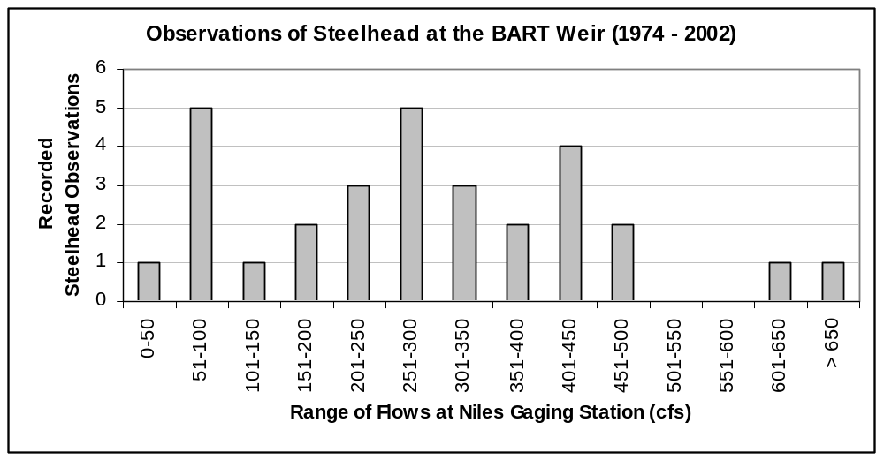
Figure 2 – Timing of recorded steelhead observations at the BART weir with respect to daily average flow at the Alameda Creek near Niles gauging station.

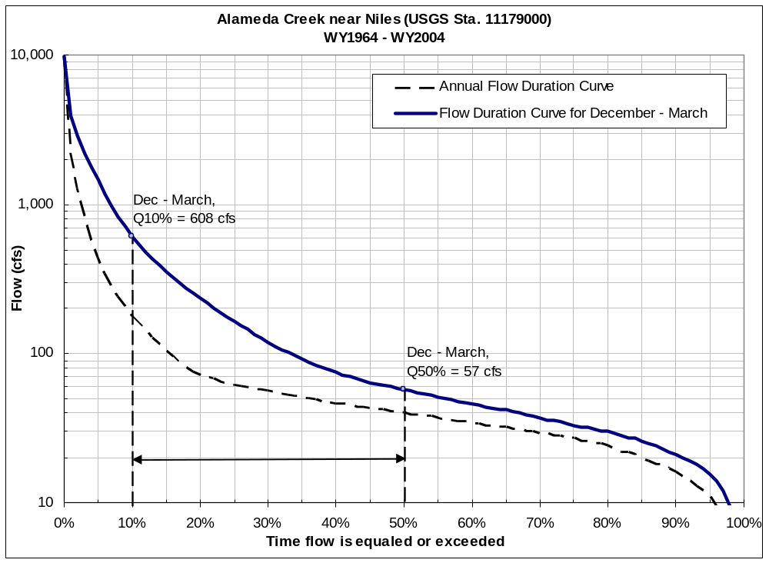
Figure 3 - Annual and seasonal flow duration curves for the USGS operated Alameda Creek near Niles gauging station. The period December through March was identified as the typical migration period for steelhead in Alameda Creek. For this assessment the 50% and 10% exceedance flows for the migration period were used as the lower and upper fish passage design flows, respectively.
The predicted Manning’s roughness coefficient was 0.040 at flows between 57 cfs and 608 cfs. Estimates of the WSE’s below the weir were validated from photos of the site at various flows (Figures 1, 5, and 6).

The water velocities and depths across the face of the weir were approximated by assuming uniform flow conditions. The cross section along the crest of the weir was used, combined with a slope of 0.19 ft/ft and Manning’s roughness coefficient of 0.015 for concrete. Although uniform flow and other assumptions associated with using Manning’s equation may not be fully satisfied when modeling such steep slopes, this method is believed to still provide relatively realistic estimates of water velocities and depths and is considered suitable for assessment purposes.

Findings

Results suggest that the flow measurement weir is a serious impediment to upstream migrating adult steelhead. At migration flows the water surface drop across the weir remains relatively constant at 3.8 feet. Since steelhead are expected to try to swim rather than leap over the weir, estimated water velocities and depths across the sloping face of the weir are presented in Table 1.

Existing California Department of Fish and Game (CDFG) fish passage design guidelines recommend providing a water depth of at least 1 foot. However, steelhead are frequently observed swimming through much shallower waters. Based on experience, for the concrete weir a more realistic threshold for defining a depth barrier is 0.33 feet.

Table 1 – Estimated water depth and velocity along the face of the weir at fish migration flows.
Flow | Water Surface Drop Across Weir | Water Depth on Sloping Weir | Water Velocity on Sloping Weir
(cfs) | (feet) | (feet) | (feet/second)
57 | 3.81 | 0.27 | 18.2
100 | 3.77 | 0.28 | 18.7
200 | 3.79 | 0.34 | 21.2
300 | 3.79 | 0.39 | 22.9
400 | 3.78 | 0.40 | 23.6
500 | 3.76 | 0.42 | 24.5
608 | 3.73 | 0.45 | 25.0

Existing CDFG fish passage design guidelines recommend a maximum water velocity for adult salmon and steelhead of 6 ft/s for distances less than 60 feet. This is within the fish’s prolonged swimming abilities. Steelhead can obtain much higher swimming speeds when swimming at burst speed. Steelhead burst swimming speeds have been reported to range between 12 ft/s and 26 ft/s (Bell, 1991). However, they can only swim at burst speeds for short periods; usually ranging between 1 and 30 seconds. Also, nearly all published swim speeds are only valid when the steelhead is fully submerged, allowing the fish to fully utilize its tail for propulsion. Therefore, when the water depth is less than the height of the fish it is reasonable to assume that the fish will not be able to obtain optimum swim speeds.

The average body height of a 24 inch steelhead is 0.46 feet (FishBase, 2006). Even though the water velocities estimated across the weir are within the very upper limits of reported steelhead burst swimming speeds, their bodies are likely less than fully submerged. The predicted velocities across the weir combined with the shallow water depths would likely impede upstream passage of all but the strongest steelhead.

Summary
The hydraulic analysis suggests the weir is a completed barrier. However, water depths and velocities are not uniform across the entire weir. For example, during higher flows water velocities along the edges of the weir are likely slower, possibly providing opportunities for some steelhead to make it upstream. Additionally, steelhead can sometimes use the friction of the concrete against their body to “crawl” up steep slopes when the water is shallow.

However, the weir may significantly delay upstream migration of individual steelhead, if not totally block them. The weir may only be passable during a limited range of flows, forcing the fish to wait until flow conditions are suitable. Additionally, many passage attempts may be required before the fish is able to find a path over the weir, using vital energy reserves needed for completing its spawning cycle. Lastly, a delay at the weir may greatly limit the distance a steelhead can migrate upstream. Flows within Alameda Creek and its tributaries rise and fall rapidly in response to rainfall events, and a steelhead has only limited time before receding flows result in water depths within the channel too shallow for the fish to swim through. If delayed at the weir, the fish may not have sufficient time to reach the suitable spawning and rearing habitat located in the upper reaches of the basin.

Recommendations

Given the extent to which the Alameda Creek near Niles flow measurement weir hinders upstream passage of steelhead, it would be prudent to begin considering options for improving fish passage at the weir in conjunction with efforts to remove existing downstream migration barriers. Otherwise, downstream fish passage may have little benefit if migrating steelhead are either significantly delayed or completed blocked at the flow measurement weir.

This report is intended to be a preliminary assessment of fish passage conditions at the flow measurement weir. There were numerous hydraulic assumptions made to estimate the water surface drop across the weir and the water depths and velocities across the face of the weir. Additional field data collection, including recording the water surface elevation below the weir at various flows, is recommended to verify the findings of this report. This field data would also be valuable in developing design alternatives for improving fish passage.

Design Alternatives
The Alameda Creek near Niles gauging station has a very extensive historic record and its continued operation is invaluable for both flood control and water supply. Given the alluvial nature of Alameda Creek at the gauging station, maintaining a hard channel control may be essential for providing the desired level of flow measurement accuracy. Modifying the existing weir while maintaining a hard channel control could be accomplished by adding one or more concrete fish ladders. Although modifications to the existing weir would require recalibrating the gages rating curve, this could likely be completed within one water year.

A pool-and-weir type fish ladder could be added to each side of the flow measurement weir. Since fish often migrate up the edges of a stream or river, providing a ladder on each side of the weir would allow them to more readily find the ladder entrance. The ladder would need to overcome a total drop of 4 feet. If providing juvenile fish passage is not required at the site, CDFG and National Marine Fisheries Service allows each weir in the pool-and-weir ladder to have a drop of up to 1 foot. Such a ladder, if designed sufficiently large, could greatly improve steelhead passage conditions at all migration flows.

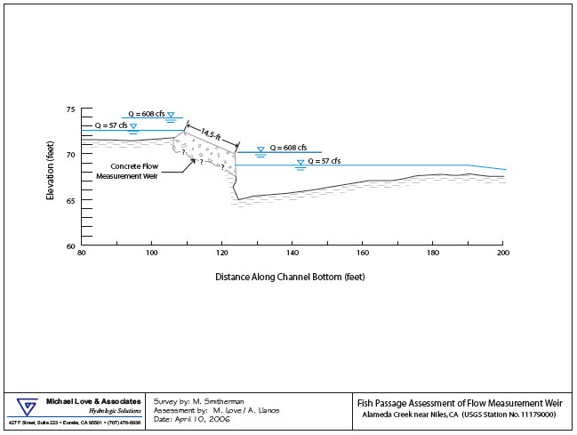

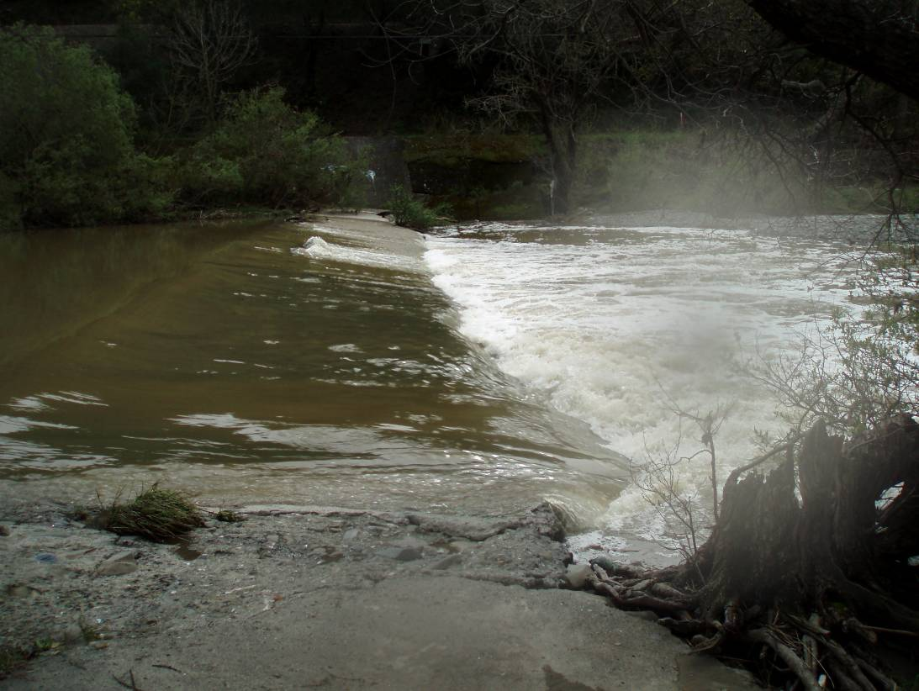
Figure 5 – The Alameda Creek near Niles flow measurement weir on 3/4/2006, 12:18 pm at approximately 300 cfs.

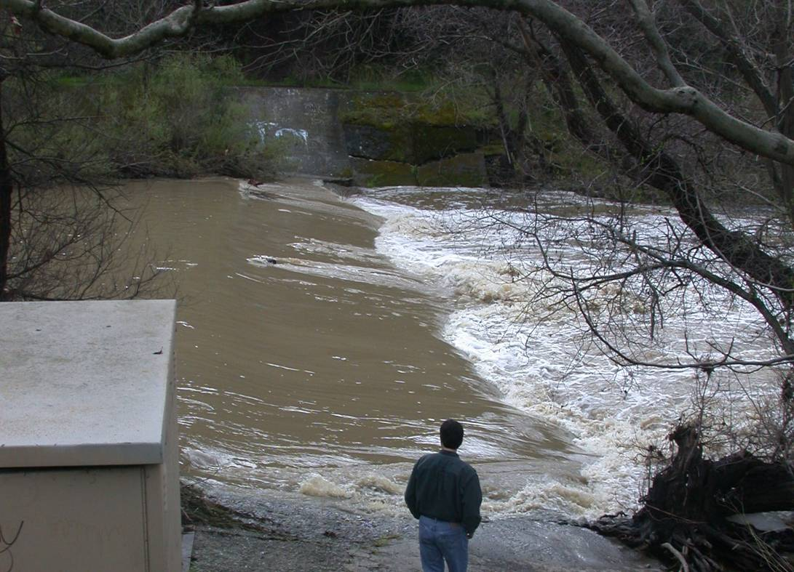
Figure 5 – The Alameda Creek near Niles flow measurement weir on 2/27/2006, 10:56 am at approximately 680 cfs.

References

Bell, Milo. 1990. Fisheries Handbook of Engineering Requirements and Biological Criteria. US Army Corps of Engineers. North Pacific Division.

FishBases, 2006. Froese, R. and D. Pauly. Editors. 2006. World Wide Web electronic publication. www.fishbase.org, version 02/2006.

Lang, M., Love, M., and Trush, W., 2004. "Improving Stream Crossings for Fish Passage." Rep. No. 50ABNF800082, National Marine Fisheries Service.

Mussetter, R.A., 1989. Dynamics of Mountain Streams, Ph.D. Dissertation, Dept. of Civil Engineering, Colorado State University, Ft. Collins, CO.

GRAPHICAL RESULTS OF FISH PASSAGE ASSESSMENT

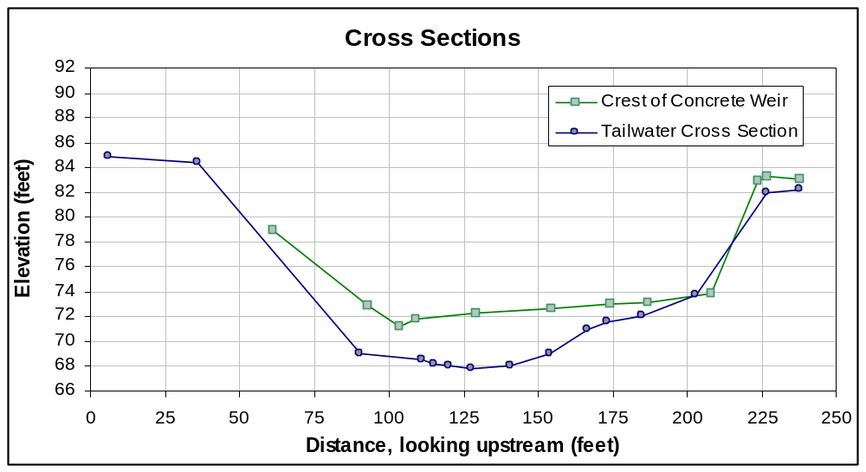
Cross sections (1) across the crest of the concrete weir and (2) across the channel at the tailwater control (crest of tailout) below the weir.

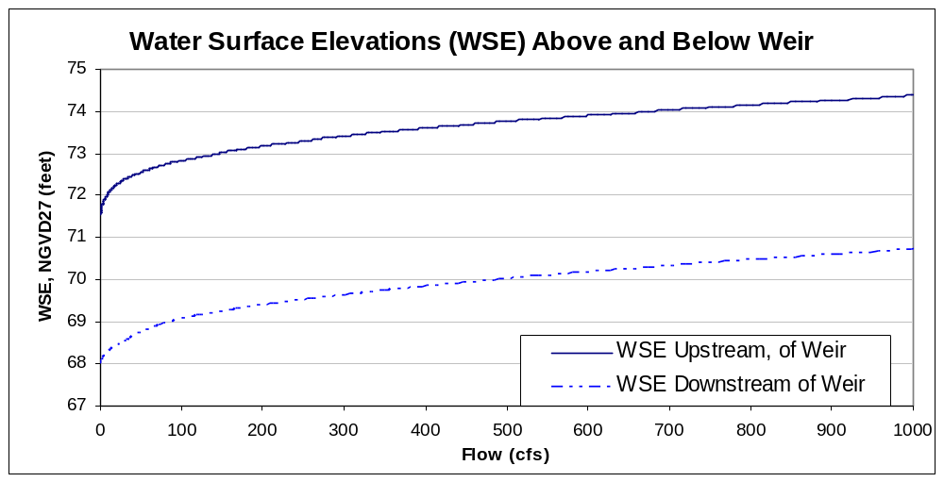
Water surface elevation (WSE) above and below the flow measurement weir at various flows. The upstream WSE was obtained from the USGS stage-discharge rating table. The downstream WSE was calculated assuming uniform flow through the tailwater cross-section, and using an estimate of channel roughness and the channel slope.
GRAPHICAL RESULTS OF FISH PASSAGE ASSESSMENT

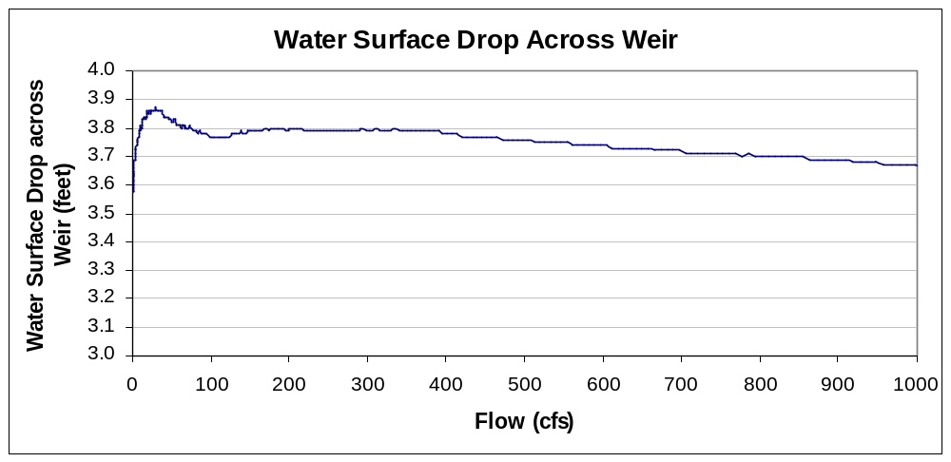
Difference in water surface levels above and below the weir, calculated by taking the difference in WSE’s from the previous graph.

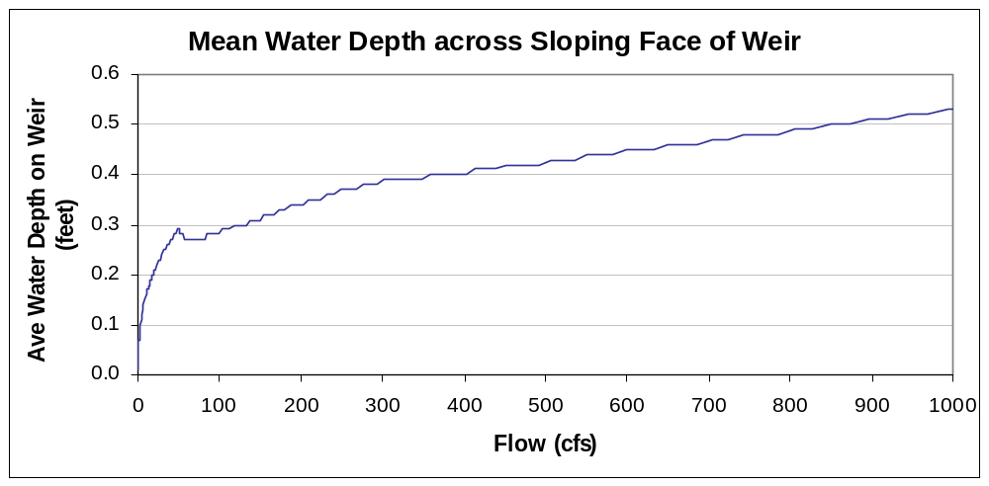
Estimated average water depth on the face of the flow measurement weir at various flows. Depths estimated assuming uniform flow conditions on weir face.

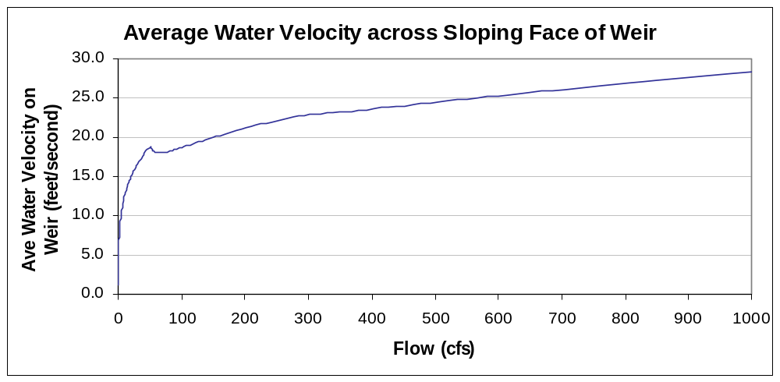
Estimated average water velocity on the face of the flow measurement weir at various flows. Velocity estimated assuming uniform flow conditions on weir face.

Alternatives Analysis

Introduction
The Northern California Council of the Federation of Fly Fishers through its Wild Steelhead Committee has supported an effort to identify a “Model Project” for the improvement of migratory fish passage. Over 20,000 barriers to migratory fish passage are known to exist on California streams that host anadromous fish. After a substantial search effort, a site located easterly of the intersection of Mission Boulevard and State Route 84 near the City of Fremont, California was secured. The site [USGS Gauging Station] is located adjacent to State Route 84 and shown on pages 3 and 5 plus in several photographs throughout this report.
The purpose of this report is to submit and comment on available studies, design information, interviews with agencies and organizations, and to verify the appropriate conceptual design [“Concept Plan”] for the location respective to the improvement of migratory fish passage.
The following discussions and assumptions are based on the information provided by the Alameda Creek Fisheries Restoration Workgroup, interviews with or written material provided by Agency and Project Contacts shown on the enclosed listing, and on field reviews only. Field reviews were conducted multiple times since 2002 and included a Land Survey in May 2005.
Subterranean field exploration, borings, or in-depth investigation was not conducted for this particular study due to the limited scope of work and budget of the “model project.” Subsequent studies may be engaged upon agreement of responsible parties who own, manage, or operate the facility. These may modify or supplement the approach to “conceptual” and/or final design and related costs if conditions are different or are determined appropriate with respect to information currently available. Funding would need to be provided.
Based on the current economic climate and its effect upon construction costs, final construction costs may vary significantly. Conceptual planning will not include a detailed estimate of final design or a Preliminary Engineers Estimate of construction costs. It is desired to include at least a “rough” estimate of the final design and construction cost for planning purposes.
For this USGS Gauging Station preliminary design and facility report, we have completed a Land Survey and Fish Passage Assessment (both enclosed) plus interviews or contacts with agencies and responsible or interested parties for the site and Alameda Creek generally.

Discussion

The facility is located along a heavily used two-lane highway. A pullout immediately adjacent to the site is signed for “No Parking” at any time. An Encroachment Permit is required from CalTrans to park in the pullout for any purpose other than operating or monitoring the facility.

The primary purpose of the concrete weir and apron is stream flow measurement. A remote sensing transmission station is located nearby. Unofficial recreational use of the site includes picnics and water play. The entire record of Alameda Creek flows at the mouth of Niles Canyon were gathered here. The concrete weir and apron is old but precise vintage is not known.

Route 84 is rural in character at this location, narrow, limited in width, and situated in mountainous terrain. The slopes in the vicinity of the roadway are very steep. Some nearby old and recent areas of slope instability are visible. Based on our observation of the cut slopes in the site vicinity, the site is underlain by a variety of soil types and bedrock. The footing of the weir and apron appear to have been undermined by the creek flows. The lowest flows over the weir follow a “notch” on the crest near the northerly bank. This can be seen in several of the low or moderate flow level photographs including the cover sheet. A pool has established itself at the downstream side of the weir below the “notch.”

Presently, the vegetated hillside slopes and stream banks are covered with a variety of vegetation including multiple tree species (some of substantial size), grass, shrubs, etc. Poison Oak is common at the site!
The survey, site reconnaissance, fish passage assessment review does not address geotechnical issues at this site, nor the groundwater seepage or reasons behind the partial foundation failure of the weir. However, it appears that age and surface drainage is a contributory factor to the problems at the site. A substantial acreage of watershed, upstream urbanized and rural lands, and releases from three reservoirs flow over the weir.

Alternatives Considered:

For purposes of these recommendations, it is assumed the fish passage improvement repair to be designed is a combination result of several constraints. These constraints include available budget, Agency and facility operator requirements, Department of Fish & Game requirements, cost control, and difficult site geometry and rural location.

[INSERT ADDITIONAL INFO FOR EACH ALTERNATIVE AND ALTERNATIVES PROPOSED OR OBTAINED DURING INTERVIEWS OR FROM WRITTEN MATERIAL OBTAINED].

Facility Removal
Removal of the concrete weir and apron would allow the stream to flush the siltation immediately upstream of the facility and “re-adapt” to a more natural slope within this reach.

Fish Ladders both sides
The Fish Passage analyst recommends potential for one or two fish ladders at this location. Discussion is included with that narrative.

The foundation of the repair should be protected against erosion and scouring for both upstream and downstream.

Measures such as providing upstream and downstream energy dissipation, resting pools and Rock Slope Protection (RSP) and revetment, etc. should be used. Due to the adjacent steep slopes within the immediate vicinity of the repairs, it is likely that debris from future (substantial) rainfall events will enter the stream corridor.

Fish Ladder Northerly Side

Consideration of a single fish ladder is included in this options analysis.

The foundation of the repair should be protected against erosion and scouring for both upstream and downstream.

Measures such as providing upstream and downstream energy dissipation, resting pools and Rock Slope Protection (RSP) and revetment, etc. should be used. Due to the adjacent steep slopes within the immediate vicinity of the repairs, it is likely that debris from future (substantial) rainfall events will enter the stream corridor.

Step Pools Northerly Side

The low flow notch near the northerly bank may provide a likely location to establish a series of “step pools” that allow upstream migrant fish to jump a sequence of one foot high steps. Retention of the existing weir structure provides an immediate resting pool upstream of the weir crest. The foundation of the repair should be protected against erosion and scouring for both upstream and downstream.

Measures such as providing upstream and downstream energy dissipation, resting pools and Rock Slope Protection (RSP) and revetment, etc. should be used. Due to the adjacent steep slopes within the immediate vicinity of the repairs, it is likely that debris from future (substantial) rainfall events will enter the stream corridor.

Cut or Build “U” Shaped Opening at low flow spill location

The photos of the site and the survey show a well defined low flow spill near the northerly bank. This location has a deep hole beneath created by higher flows and natural erosion and energy dissipation action. It may be a likely spot to modify and repair the weir by creating a fish passage jump with associated step pools etc.

Recommended Alternative

Due to these conditions, it is recommended ................................................. inclusive of energy dissipation, and slope fill/repair to reconstruct the roadway slopes used for stream access. The repair design(s) would be initiated with the understanding that the area will be subjected to potential severe storm stresses and potential damage to the repaired/modified facility caused by storm events and the existing and adjacent upstream environment.

Route 84 is assumed to remain open at all times for construction at this location.

The final costs for Plans; Specifications & Estimates of construction costs [PS&E] are preliminarily estimated.............................................................

Concept Plan Alternative Concurrence:

By: ________________________________________
[Authorized Alameda Creek Agency Representative]
Date: ________________

Comments: _________________________________________________________________________

_________________________________________________________________________

_________________________________________________________________________

_________________________________________________________________________

_________________________________________________________________________

_________________________________________________________________________

_________________________________________________________________________

_________________________________________________________________________

Concept Plan Alternative Concurrence:

By: ________________________________________
[Authorized Alameda Creek Agency Representative]
Date: _________________

Comments: _________________________________________________________________________
_________________________________________________________________________
_________________________________________________________________________
_________________________________________________________________________
_________________________________________________________________________
_________________________________________________________________________
_________________________________________________________________________
_________________________________________________________________________

_____________________________________________________________________________

Environmental Review Requirements
It is unknown at this time the extent of Environmental Review. Compliance with NEPA and CEQA could be minimal [FONSI or Negative Declaration] within the context of other fish passage projects considered along Alameda Creek. Alternatively, agencies may be more sensitive and require full environmental review.

_____________________________________________________________________________

Construction Permitting Requirements
The following agencies may require various permits:
RWQCB Waste Discharge Requirements or Water Quality Certification
DFG a 1601 Stream Alteration Permit
CalTrans an Encroachment Permit to enter the site from the No Parking Zone along Route 84
SFPUC
Alameda County Flood Control
Written agreement with USGS and agencies utilizing stream flow data collected at the site.
Other(s)

Agency and Project Contacts

Alameda County Flood Control and
Water Conservation District

Erika Cleugh
Ecleugh@dfg.ca.gov
399 Elmhurst St.
Hayward, CA 94544
(510) 670-5480

Alameda County Flood Control and
Water Conservation District

Laura Kilgour
Laura@acupa.mail.co.alameda.ca.us
399 Elmhurst St.
Hayward, CA 94544
(510) 670-5480

Alameda County Flood Control and
Water Conservation District

Carla Schulteis
Carla@acpwa.mail.co.alameda.ca.us
399 Elmhurst St.
Hayward, CA 94544
(510) 670-5480

Alameda County Flood Control and
Water Conservation District

Richard Wetzig
Rickw@acpwa.mail.co.alameda.ca.us
399 Elmhurst St.
Hayward, CA 94544
(510) 670-5480

Alameda County Water District

Eric Cartwright
Eric.cartwright@acwd.com
43885 S. Grimmer Blvd.
Fremont, CA 94538
(510) 670-5480

Alameda Creek Alliance

Jeff Miller
Alamedacreek@hotmail.com
P.O. Box 192
Canyon, CA 94516
(510) 499-9185

American Rivers

Steve Rothert
Sothert@amrivers.org
P.O. Box 559
Nevada City, CA 95959
(530) 478-5672

California Department of Fish and Game

Manny da Costa
Mannyd@acpwa.mail.co.alameda.ca.us
399 Elmhurst St.
Hayward, CA 94544
(510) 670-5480

California State Coastal Conservancy

Brenda Buxton
Bbuxton@scc.ca.gov
1330 Broadway, 11th floor
Oakland, CA 94612
(510) 286-0753

CALTRANS

Encanta Engleby
engleby@dot.ca.gov
District 3
P.O. Box
Marysville, Ca 95901
(530) 741-4211

Center for Ecosystem Management
and Restoration (CEMAR)

Andy Gunther
Gunther@cemar.org
4179 Piemont Avenue, Suite 325
Oakland, CA 94611
(510) 420-4565

CH2MHill, Inc.

Darryl Hayes
Dhayes@ch2m.com

Department of Water Resources

Bill Bennett
Bennet@water.ca.gov
P.O. Box 942836
Sacramento, CA 94236
(916) 653-5791

East Bay Regional Parks District

Peter Alexander
Palexand@ebparks.org
2950 Peralta Oaks Court
P.O. Box 5381
Oakland, CA 94605

Golden West Women Flyfishers

Anne-Marie Bakker, President
Anne-Marie_Bakker@berlex.com
1295 Calle del Arroyo
Sonoma, CA 95476
(707) 939-0932

Golden West Women Flyfishers

Cindy Charles, Conservation Chair
Cindy@ccharles.net
1403 Willard St.
San Francisco, CA 94117
(415) 759-0232

National Marine Fisheries Service/NOAA

Gary Stern
Gary.stern@noaa.gov
(707) 575-6060

Northern California Council Federation of Flyfishers

Mark Rockwell
Summerhillfarmpv@aol.com
19737 Wildwood West Dr.
Penn Valley, CA 95946
(530) 432-9198

Pacific Gas and Electric Company

Stuart Moock
Swm2@pge.com

San Francisco Bay Regional Water
Quality Control Board [NEED CURRENT CONTACT as of 5-24-2006]
1515 Clay St., Suite 1400
Oakland, cA 94612
(510) 622-2300

San Francisco City Attorney’s Office

Josh Milstein
Milstein@ci.sf.ca.us
850 Bryant St, Room 322
San Francisco, Ca 94103
(415) 553-1754

San Francisco Public Utilities Commission

Steve Apperson
Sapperso@puc.sf.ca.us

1155 Market Street, 4th Floor
San Francisco, CA 94103
(415) 554-3155

San Francisco Public Utilities Commission

Joe Naras
Jnaras@puc.sf.ca.us
1155 Market Street, 4th Floor
San Francisco, CA 94103
(415) 554-3155

San Francisco Public Utilities Commission

Anna Roche
Aroche@puc.sf.ca.us
1155 Market Street, 4th Floor
San Francisco, CA 94103
(415) 554-3155

U.S Army Corps of Engineers
Bill de Jager
Wdejager@spd.usace.army.mil

Zone 7 Water Agency

Jim Horen
Jhoren@zone7water.com
100 North Canyons Parkway
Livermore, cA 94551
(925) 454-5000

Zone 7 Water Agency
Mary Lim
Mlim@zone7water.com
100 North Canyons Parkway
Livermore, cA 94551
(925) 454-5000

Zone 7 Water Agency

Vince Wong
Vwong@zone7water.com
100 North Canyons Parkway
Livermore, cA 94551
(925) 454-5000

List of Attachments
1. [None as of 5/24/2006]

